Chapter Three

The Detroit/Idanha

Community Resource Unit

Section One:

Baseline Social and Economic Information

A. Community Description

Geographic Features

Figure Seven shows the Community Resource Unit of Detroit/Idanha. The unit stretches from the crest of the Cascade Mountains and the Warm Springs Indian Reservation on the east, well into Clackamas County and the Mt. Hood National Forest on the north, midway between Detroit and Gates on the west, and into Linn County on the south to incorporate the North Santiam watershed.

There are some divisions within Detroit as well. A number of residents talked about “this side of town” or “their side of town.” It refers to the layout of the town and the debate about where businesses should locate to take advantage of visitor traffic.

Settlement Patterns

Detroit was incorporated in 1952. It had 265 people in 1990 and 262 in 2000, a decline of 21%. Idanha was incorporated in 1949 and had 370 people in 1990 and 232 in the year 2000, a decline of 3% (Census Data, Table Two). Both communities were begun in relation to the construction of the Detroit Dam. Built as a flood control project and as a power generator source, it was completed in 1953. The lake has 3000 surface acres and 33 miles of shoreline, and is stocked with hatchery-raised rainbow trout. It also supports populations of land-locked Chinook salmon, kokanee, and brown bullheads (catfish) (www,fs,fed.us/r6/fishing/regional/gofishing/wil lakes).

Figure Seven

Map of the Detroit/Idanha Community Resource Unit

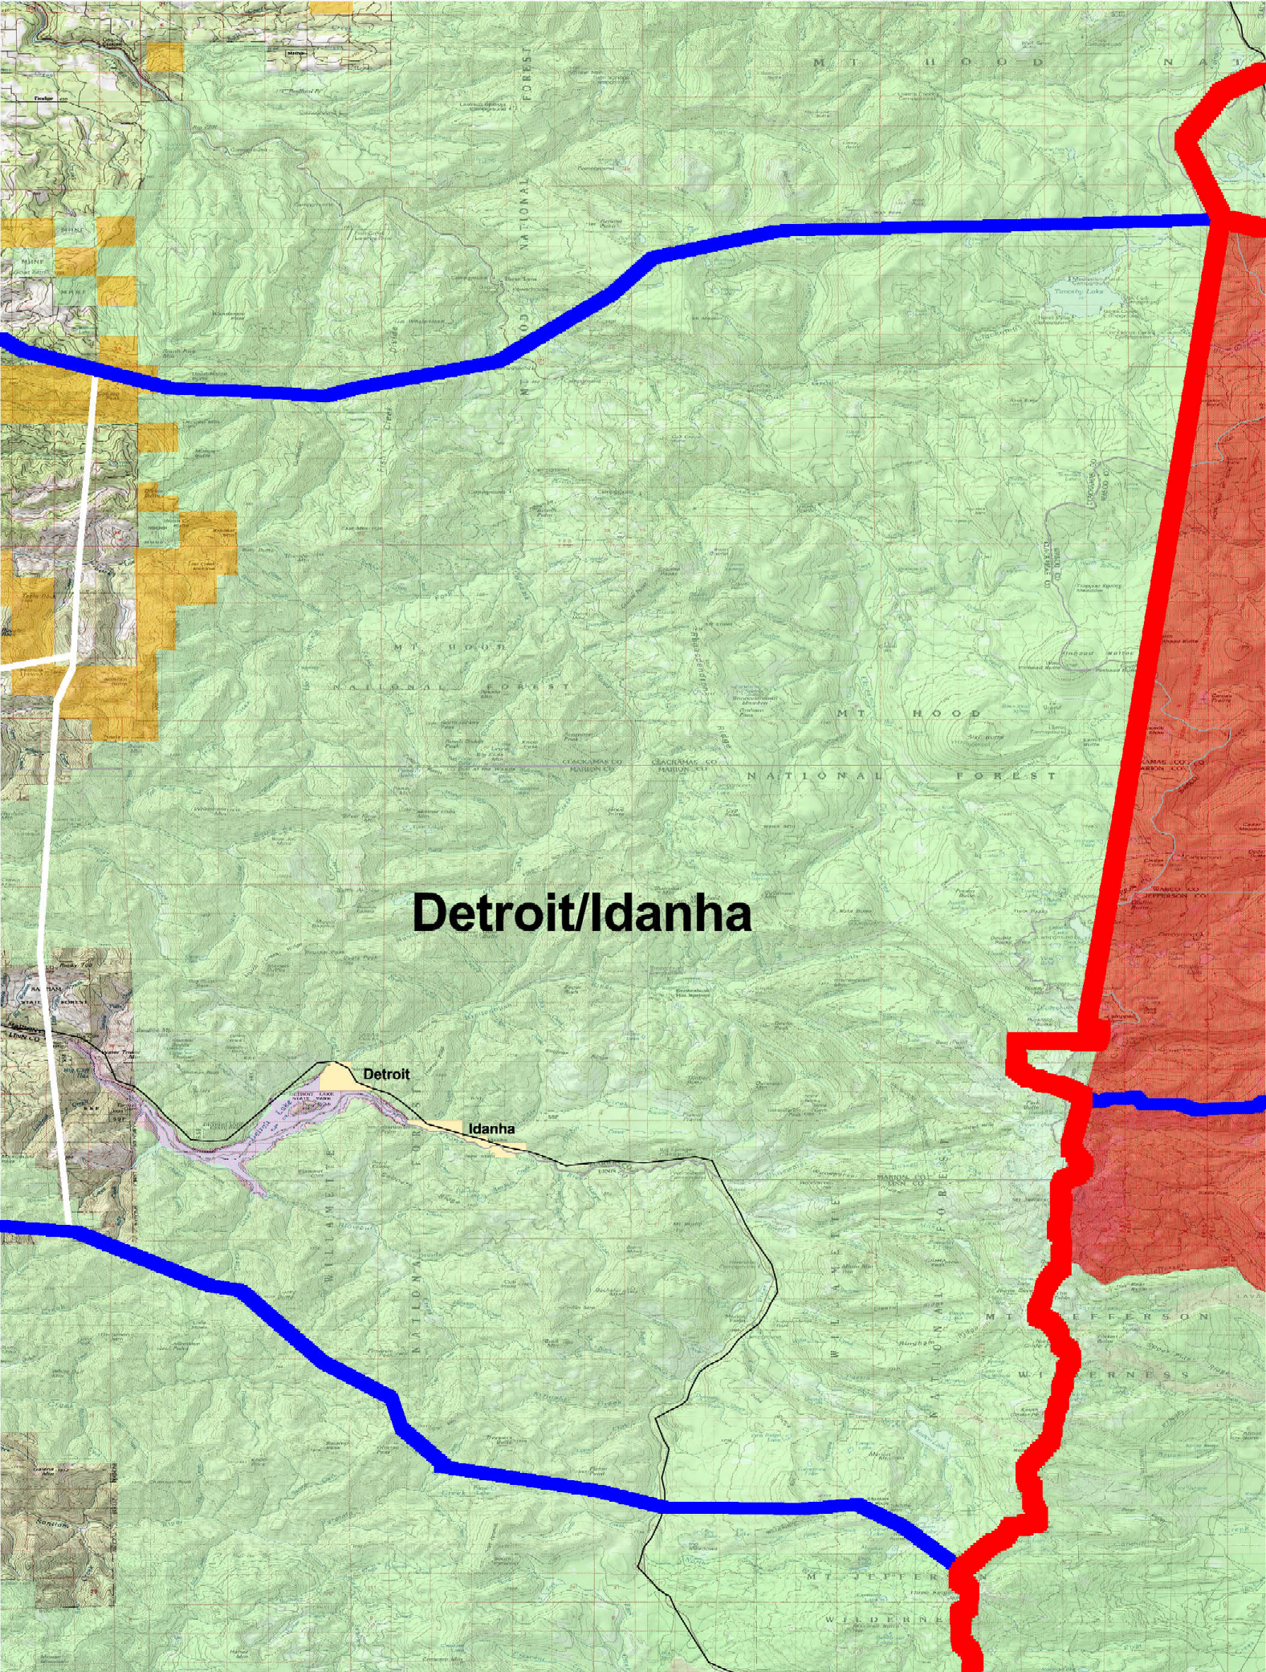

Detroit and Idanha are only three miles apart. It is clear that the two towns are closely linked and have realized that working together makes each stronger. Detroit, by virtue of the lake, is the recreation center. Idanha, by virtue of flat land, could be the industrial center. A new subdivision is being built just on the edge of Detroit, with mid-sized lots right along the river. It is expected that these lots will be for “wealthy retired folks.” Real estate activity is said to be low at the moment. A number of people leave the community in the wintertime.

“Seventeen years ago, I knew everyone in town. Now, there are lots of people I don’t know.”

“I moved here for the kids. I graduated high school at Detroit and moved back to Idanha after my kids were born.”

“We couldn’t hide here if we wanted. The first day we moved in, all the neighbors came to welcome us. We feel very fortunate.”

Figure Eight shows a photo of Detroit Lake.

Figure Eight
Photo of the Community of Detroit
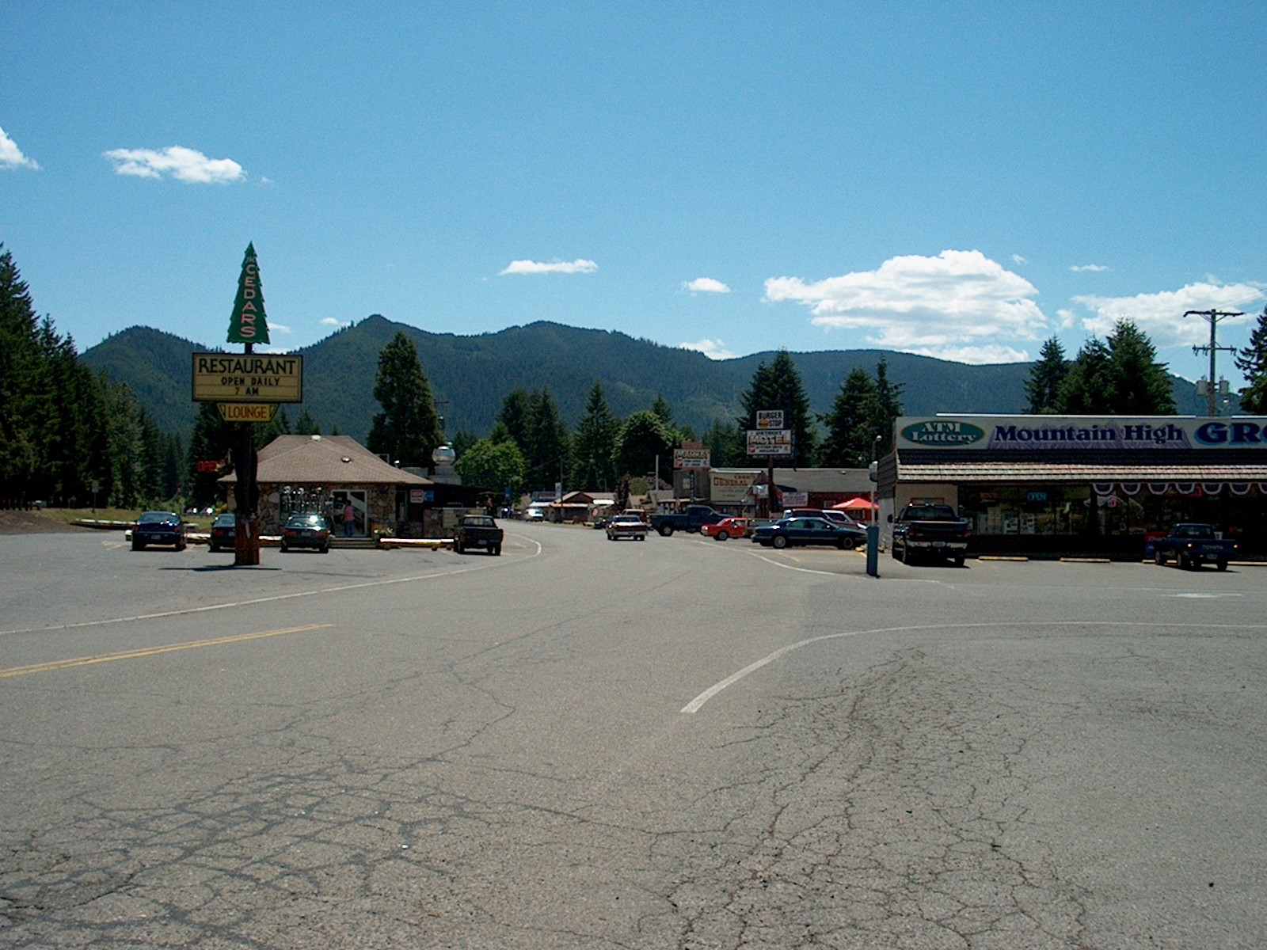

Publics

One well-known resident said there were three types of people in Detroit, business owners, summer homeowners and loggers or former loggers. Former loggers are perceived to be against any kind of growth and otherwise do not get very involved in civic affairs.

“The only time you see them [loggers] is when there is an issue related to tax increases, safety issues, or the schools.”

It only takes newcomers a couple years to be accepted and to get involved. Even seasonal homeowners get involved over time and participate in community events. Out-of-area business people are represented in the area. For example, truck-based food vendors from Salem, Beaverton and elsewhere sell in the area during the summer.

A number of residents described the older generation of business and political leadership as being in the background. There is a feeling in town that newer folks are taking over and most people thought this was a good idea. The older generation is credited with moving the community from a timber economy to a recreation economy, and the newer leadership as further developing and broadening tourism activities. Old timers even lost one of their gathering places as a local café was taken over by new owners and the side room made into a gift display featuring local artist crafts.

Networks

Refer to Section Two.

Work Routines

Local residents were quick to point out that timber is no longer the economic base. The last big mill, “Green Veneer,” closed about five years ago, and that was the last large employer in town. A window manufacturing facility opened in 1998 and employs about seven people.

One person noted that the town has gotten over its initial anger and frustration over losing the timber industry, and is starting to accept more that “cabins and tourism is the way that rural life will be.” [109] Other residents point to their resistance in becoming a tourist town. For them, the “replacement value” of the timber economy is not tourism but some other commercial endeavor.

“I moved here with my husband when he got a job in one of the mills. It closed 8-9 years ago. Of those that stayed, some got jobs further down the canyon and some like my husband became truckers. Trucking fits the logging mentality—the independence, the driving.”

“Green Veneer had 2-3 shifts but 90% of the workers lived elsewhere, as far as Mehama.”

“When Freres lumber laid off a lot of people in the late 1980s, that hurt us.”

“My last mill was Green Veneer, and before that Young and Morgan.”

“We saw the mills close down, one by one. Then the school began to cut down. The high school was the first school in Detroit that closed.”

Woods products employment continues to be an important source of jobs. Small-scale and private logging continues. There is reportedly a large operation, based in Lyons, making Christmas tree wreaths. One local gentleman uses poles from “trash” trees for his willow furniture. A small number of other people familiar with the woods are orienting themselves to visitors.

“Local folks often refer out-of-towners to me for tips or guiding on forest hikes. I take people out or show them where to go.”

It is clear that at least at present, the leadership of the communities is oriented around tourism development. Particularly in light of the slow season experienced last year due to low water levels at Detroit Lake, political and business leadership appears united in fostering greater cooperation in developing the tourism sector.

“You can’t start a new business in Detroit without helping the community. The new owners are about change.”

Support Services

Long-term plans are underway to build the infrastructure of both Idanha and Detroit. These include a sewer system, road improvement, and turning the old Detroit school (now a “blight in this small town”) into a multi-service community center (gym, pool, services, meeting area, kitchen). The new infrastructure will make it easier for business and industry to locate in the area.

“Businessmen Association” meetings are perceived by some to be dominated by a prominent family and by men.

“Oh, we don’t go to the meetings.”

Economic transition has been difficult for vulnerable families, leading to dislocation, stress, and reliance on agency services. Residents have also noted that more low-income families have located in the area in recent years.

“When the two mills were still operating 7 years ago, out of 100 families here, only one was receiving any assistance and we used to look out for her. She was a single mother. Since the loss of timber, there has been a major influx of people on public assistance. Cheaper housing draws them, I think.”

“The housing units have fallen into disrepair since timber left.”

A group of people coordinates Christmas gift boxes through the Detroit Community Church.

Schools are an important support service:

“The high school was the first school to close in Detroit. As the mills closed one by one, so did the schools. If you don’t have a school in the community, you lose your sense of community.”

The charter school, started in Detroit as a strategy to deal with declining enrollments, was described as “the pride and joy” of the community. It symbolized the fact that the community was able to work together to achieve a common end. The charter school reportedly is closing, however.

Breitenbush Hot Springs has been operating for 25 years as an intentional community, cooperative, and as a retreat and conference center. It adds significantly to community life and to the local economy.

This area is known for its strong informal caretaking. It is one of the areas where pride in living in a rural area is evident.

“The other night, I had to get my father to the hospital, but I couldn’t open my front door because of the snow. The ambulance couldn’t get near the house. I used the phone tree and within minutes, friends were digging me out.”

Recreational Activities

Refer to Section Three.

B. Trends, Citizen Themes and Issues

Related to Community Life

Trends

A strong shift away from timber dependence to recreation dependence.

A change in how public lands are used.
“People you run in to in the woods are not timber people now, but people gathering special forest products. Many of these people are from the valley.”

Themes

1. “We can’t depend on the Lake anymore.”

“People don’t work in the woods anymore, but play in the woods. Now, people work in the cities.”

2. “The transition is still underway.”

“This area still has a hard time with the forestry ban. Most people have either moved on or adjusted—the issue isn’t so ‘loud’ anymore. People are not so comfortable with tourism. We’re a mill town. They’re not liking the idea of strangers everywhere, using telephones and restrooms, walking through their yards, staring at the town.”

“People say we’re not rural anymore. They say you can’t sled down the same hills that you did as a kid because there are houses there now. But we’re still rural.”

“In the timber days, everyone knew the rules, even with environmentalists. Now the roles are fuzzy. People are not always sure how they are supposed to relate.”

Citizen Issues

General

“Business development is not good.”

“We want to create a small and safe kids park right next to downtown for families as they come through.”

“We have drug houses. You can tell by all the cars parked there. And we have theft in the summer houses.”

“The town has too many speculators. They buy land for future development, but don’t do anything with it for years.”

Residents make gender distinctions in this area based on outlook and interests.

“It is the men in the meetings telling what will be, and the women are the ones that always carry it out, even though most of the business owners are women. We are going to start a ‘business women’s association.’”

The new sewer system has been “brewing” for nine years and there are still a number of unresolved issues.

“How will the new sewer work? How much will we have to pay? Will we have to operate our own private pumping stations?”

Section Two:

Communication Strategies

A. Informal Networks and Communication

Gathering Places

KC’s coffee shop in the morning
The hardware store in Detroit
Mountain High Market
Kelly’s coffee house, old timers meet regularly
Kane’s Marina is a communication spot during the summer months.

Mail is not delivered in this area, so those within a half-mile of the post office must pick up their mail. The Post Office, consequently, is a place where people visit and share information.

“If you live in town, then you have to come and pick up your mail at the post office. I see everybody there.”

Key Community Contacts

Mia Mohr is part of the Economic Development Corporation (see below) but a crucial local contact.

Tee Berthel; (503) 854-3204; 168, email: berthels@open.org, Repose and Repast Bed and Breakfast.

B. Formal Groups and Communication

Figure Nine

Organizations With Interest in Public Lands in Detroit/Idanha

Organization | Contact Information | Mission
Save Our Lake | www.geocities.com/  saveourlake | Maintain water levels of Detroit Lake; organize businesses to work together.
Advisory Council for Opal Creek
North Santiam Chamber of Commerce | 833 NW Santiam Blvd.  Mill City, OR  (503) 897-2865 | Jobs and business development
North Santiam Snowmobile Association |  | 120 members  joint brochure with USFS  Cooperates with the Forest Service on trails, shelters, and outreach.
Breitenbush Hot Springs Retreat and Conference Center | P.O. Box 578  Detroit, OR  (503) 854-3314 | A retreat center with diverse clientele
North Santiam River Guides | Bill Sanderson  897-3301
North Santiam Watershed Council | P.O. Box 855  Stayton, OR 97383  (503) 859-4341  nsantiam@open.org
Chemetekan Hikers | Salem
Equestrian groups
North Santiam Canyon Economic Development Corporation | Mia Mohr  833 NW Santiam Blvd.  Mill City, OR  (503) 897-2295

Section Three:

The Public Lands Perspective

A. Uses of and Orientation to Public Lands

Detroit Lake is one of the most popular visitor spots in the state, attracting people from a wide region and fostering repeat visits by many within the region. The local Forest Service office stated that 40% of the visitors are from Portland. There are two marinas in Detroit and one of these has recently been purchased by a gentleman from out-of-town who stated he was attracted to the area because of the friendliness of the businesses and the cleanliness.

Local people highly value Detroit Lake. One person boasted that 85% of Oregon boaters came to Detroit Lake to play every year. “This lake was found to be the most boated lake in the state,” said another. Detroit Lake is now nominated as a Federal Lakes Recreation Demonstration Project through which it may receive funds to foster recreation and tourism in the area.

When the drought and low water levels reduced the tourist season last year, the community was devastated. Dramatic economic losses were posted by local businesses. The impacts compelled elected and business leaders to focus on minimizing low water years in the future to the extent possible, and on diversifying the recreation opportunities for visitors so that the lake would not be the only destination. The Forest Service experience was that, if the lake was not the destination, visitors chose completely different areas rather than coming to the Detroit area and engaging in other recreation activities. Our findings confirm this. Visitors we talked with said the only reason they came to Detroit was for the lake. Many said that when the lake is not a destination, as during last year’s low water, they prefer to go to points farther east.

The determination and resilience in the community was demonstrated by one response to low water. Two residents approached a Harley motorcycle club out of Portland with the idea of coming to Detroit for a one day BBQ. The club really liked the idea and about 250 people showed up. Another couple hundred were turned away because “we had to draw the line somewhere.” The event was a big success and the couple plans to expend the event this year.

“We can’t always depend on the lake being full.”

The Detroit area has a number of public events that bring visitors into the community. The area has had a Fishing Derby for the last 20 years, a Fourth of July event, and a car and motorcycle parade. The Detroit Area Holiday Festival just completed its 6th year and there was recently a 50th anniversary celebration of the town.

A snowmobile club helps the Forest Service with trails, shelters and outreach. There is a Boy Scout camp above Marion Fork.

“Hiking visitors are looking for the lookouts—whether or not there are buildings there or not. Other popular spots are Marion Lake, Boca Cave, South Breitenbush trail system, Firecamp Lakes, Bear Point, Coffin Mountain, Gold Butte and the Gold Mine.”

“People come into the woods to pick berries for their own use—huckleberries, blackberries and elderberries.”

Forest Service staff expressed a belief that rural people believe “we are looking past them” to the urban areas and are less attuned to rural interests. Old families feel left out. Apparently, it is not as easy for Forest Service staff to tap into traditional rural networks as in years past.

Forest Service staff reported that timber sales are down 80-90% of what they used to be but may start up again. Special Forest Products has become one of the most active programs in the state, generating $100,000 or more in revenue. The mills have retooled but the market is not good because of high import volumes.

The Forest Service has been active, and appreciated, in community development efforts over the years. Recently, it has helped with replacing the dike in Idanha, technical assistance for the new sewer system, designation of Highway 22 as a scenic corridor, creation of a “portal” for visitors, as well as funding of the Mill City museum, feasibility studies and economic diversification projects.

In talking with numerous storeowners, it is clear that they are the first line of information for visitors in the area, and they are well-informed about Forest Service activities and information. They related positive attitudes about their relationship with the agency.

B. Trends, Themes, and Citizen Issues Related to

Natural Resource Management

Trends

Forest Service people live elsewhere. We were told that of 42 staff people at the Detroit District, ¼ live in Detroit, ¼ in Mill City to Mehama, and ½ reside in valley communities.

An increased dependence on recreation.

Themes

1. “The Forest Service has become more responsive.”

“The Forest Service has become more responsive to people’s concerns since the environmentalists and timber industry butt heads.”

“The Forest Service has been active in the planning of the infrastructure development (sewer, water, and highway).”

The Forest Service has been in active partnership with Detroit and Idanha, including:
- A new visitors’ portal to be built west of Detroit;
- Support in replacing the dike in Idanha after it was destroyed by the flood of 1996;
- Use of the Northwest Forest Plan funding for a feasibility study and for an Economic Development and Diversification Program;
- Technical assistance in the effort by the towns to construct a new sewer system;
- The Main Street Concept, designed to unite the canyon communities in addressing economic development concerns, fell through, apparently through the inability of the local communities to transcend past difficulties.

2. “Cooperation pays off.”

“If all these canyon towns could come together, we would have more clout at the state and federal level. Speaking with one voice of 5000 has more power than just a couple hundred people. People focus too much on the differences, rather than the likes.”

Forest Service Management Concerns

Forest Service personnel assigned to the Detroit Ranger District shared these management concerns related to public lands under their care:

Law enforcement is a problem. There are lots of visitors but few staff. “Detroit on Saturday night is like Las Vegas without the gambling. It’s party time.”

Trash and vandalism at the campgrounds are a problem. People don’t feel safe. It’s slowly improving—Marion County found money somewhere and will now have two law enforcement people.

The roads and trails are not in good condition. Many are unmarked and people get lost. One favorite visitor activity is driving the roads but they are not maintained like they used to be. There are issues of communication when we close roads.

Are reserved campsites an issue? A lot of people prefer dispersed sites, Upper Arm is overused and it may be made a day use area.

Some people launch boats from the campgrounds and that’s a problem.

Forest Service and powerline roads are popular with OHV riders. Many areas are just too steep. Some ride too fast and that becomes a law enforcement issue.

Citizen Issues

General

“The forest is for out-of-town people and not for people who live here. For example, trees are not removed from the roadside for aesthetic reasons for visitors.”

Fire
“With all the newcomers and visitors, we worry about fire protection. They don’t really know about how to do fires. I’m surprised there weren’t more fires last summer than there were.”

Riparian Treatment

“The State of Oregon has set riparian standards that back into our living rooms! Where are these new criteria coming from?”

“I don’t know who’s putting out the new riparian rules. Who do I talk with?”

“I’m upset that the Forest Service is keeping two log piles in the river where they have been since the last flood. With all this snow, there’s a good possibility they could take down one of our bridges, and then all the people on the other side will be stuck. They are bigger than they need to be for fish habitat.”

“The flood wood in the creek is a threat to land and home.”

Water

“The state and federal government regulations call for water testing that is expensive. For a small town like ours, it costs a lot to do these tests.”

Homeless

“There are homeless people that use the forest in the summer. I see them walking on 22 into town.

Roads and Access

“Any improved recreational access to the forest is good.”

“We used to get in the truck and go into the forest for hunting and fishing on the backroads. Now the roads are so deteriorated we can’t go.”

“The Forest Service should designate an ATV trail to the cabin it rents out in the winter to snowmobiles.”

“There should be a mountain bike trail from Mongol to other campsites and on to town.” [raised by a number of residents]

Recreation

“There’s not enough dispersed campgrounds. The woods are too full of people who are improperly camping. They bring the threat of fire.”

“We need better horse and bike paths, with turn arounds and maps with distance and difficulty.”

“If the community really wants tourism and the Forest Service is supposed to help, we have to find the money to improve the trail system. Many trails are in poor shape, neglected. They need an overhaul.”

“Trail clearing is a lost art. The hiking club is too labor intensive. Trails are now too narrow. The Forest Service needs to have better supervision or contract out to new clearers to maintain the trails.”

“Where is the money going to come from to put a trail around Detroit Lake?”

“Those of us who grew up here fish, hunt and hike in the woods. We appreciate and take care of the woods. Those who moved here, don’t really know the forest very well. I find more trash in the woods than before.”

“Get more bathrooms around the lake.”

“All season camping should be available, like the yurts built at the coast.”

Detroit Lake

“A lot of people realize now that the lake can’t be the only draw for tourists. This was seen last year at the meetings the town had to address low water levels.”

Timber

“The Forest Service consults with us regularly but not the State. There was a sale recently of timber on the hill behind the town [Idanha]. It is so steep and it’s right behind a neighborhood.”

“This area was the biggest moneymaker in the Forest Service system. Where are some of those dollars now? The pressure to sell timber translated into being mined out suddenly with no options.”

“Private forest lands now are taking a beating. They are being forested too much, too soon.”

Information

“We can’t get good maps and the trails are not well marked. I have been here for three years, and it is still confusing which trials go where. Tourists are not going to start down a path when they don’t know where it’s going.”

“Inform visitors and educate locals as to where and which trails have parking and at least turn-around areas.”

“Shop owners should meet with the Forest Service to learn the trails so they can assists tourists.”

C. Management Opportunities

Communication Opportunities

The Forest Service has some key staff working in a community-interface capacity. Stephanie Phillips’ name came up numerous times in conversations with residents. It is evident that she is well regarded for the leadership role she has played in fostering community development and transition. In addition, Dani Rosetti offers a huge advantage because of her communication style and the breadth of her contacts. It is clear that, because of the informal networking that Dani does in the gathering places, she has been able to prevent many emerging issues from becoming existing or disruptive. In several instances she was able to provide accurate information to residents and to refer them to others, as for example, with misunderstandings related to road closures.

“Stephanie has been a champion for Detroit. She has gone out on a limb for us. She comes to our meetings. She is very proactive on the issue of the proposed trail around the lake, Opal Creek and the sewer project.”

“I know about 75% of the Forest Service workforce on a first name basis because of working on projects with them.”

This combination, Stephanie engaged at the formal level and Dani at the informal, offers a capacity for the agency that should be deliberately fostered. This capacity could be used to target emerging management concerns in the agency to prevent their disruption at the citizen level.

Focus on the distribution of staff people, encouraging them to be civically engaged and to focus on networks and emerging issues; have a process to collect this to broaden staff knowledge and to coordinate information.

“We are a marriage with the Forest Service. They can’t act without impacting us.”

“Downtown Salem has to be involved in forest issues up here. There are financial and environmental effects.”

Storeowners in Detroit are conscious that they are the frontlines for the Forest Service in dealing with visitors’ questions.

Canyon cooperation among the various entities could be fostered by linking them with residents in Monmouth, Independence and Dallas who have transcended a similar, conflictive past to successfully obtain grant money for issues of regional concern.

Mayor meetings happen on a regular basis in the canyon.

Action Opportunities

Do a living history project.

Broaden visitor interests so people come here even when the Lake is low. [Wide citizen interest]

“Could the Forest request items from Fort Lewis that the Shed Ed program needs (foul weather gear, etc.) and then loan them to the educational program?”

This page intentionally left blank

