Chapter 16
The Albany Community Resource Unit

Section One:

Baseline Social and Economic Information

Community Description

Geographic Features

The Albany Community Resource Unit includes the communities of Albany and Millersburg. On the north, it goes to the south of Jefferson, on the south it includes Tangent and almost to Shedd, on the east it goes to the intersection of Knox Butte Road and Highway 20 (the Santiam Highway), and on the west it goes to beyond Bowers Rock State Park almost to Independence Road. Figure 47 shows a map of the CRU.

Settlement Patterns

Albany began as a river town, thriving on agricultural commerce and trade from the earliest days of white settlement. The political divisions in the community between Republicans and Democrats date from early settlement and debates about the Civil War. According to some local residents, Lyons Street is still the marker between East Albany (Democrat) and West Albany (Republican). Figure 48 shows Albany neighborhoods.

Albany generally had a stable population of about 1000 people from 1850 to 1880. Then with the onset of railroad and shipping, it became known as “Hub City,” which resulted in an increase of population and housing in the 1880s. That explains the proliferation of so many Victorian homes that are still around. When Highway 99 and Interstate 5 were built, they bypassed the older commercial and residential areas, leaving intact a range of architectural styles dating from the 1850s. In the historic districts of Monteith, Hackleman, and Downtown Commercial Historic, there are 700 historic homes, for which there are many tours throughout the year (www.el.com/to/albany/).
Figure 47
Map of the Albany Community Resource Unit

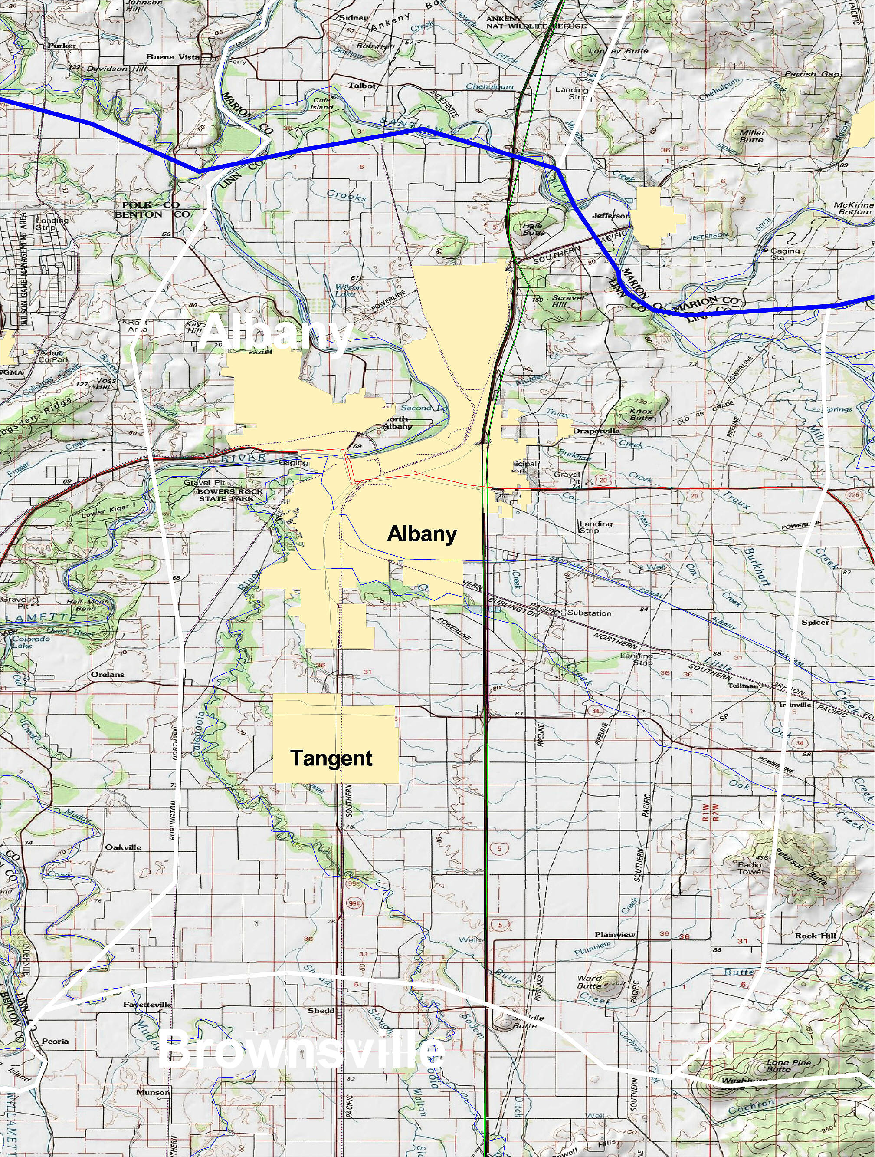
Figure 48
Map of Albany Showing Neighborhood Resource Units

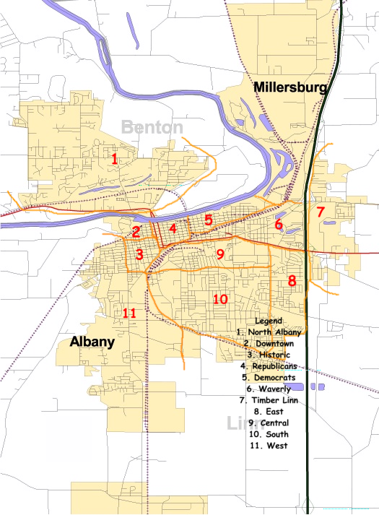

Figure 49
Historic Building at Broadalbin and 2nd Ave SW, Downtown Albany
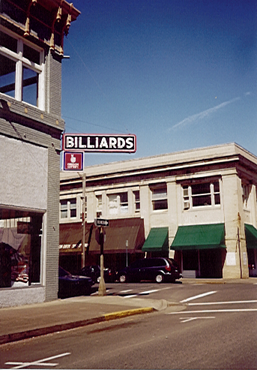

Albany is the Linn County seat. It was founded in 1848 and incorporated in 1864. In 1990, there were 34,279 people in Albany, and in 2000, there were 40,852, an increase of 16% (Census Data, Table Five).

Albany is known in the region as a “blue collar town,” and certainly its industrial past, and rows of small, neat homes give evidence of this past. However, in the last 12 years the city has dramatically shifted from industrial to residential development and to trades and services sectors.

According to city officials and local residents, many or most of the newcomers are commuters. Relying on the urban job markets of Salem, Corvallis, and Eugene, these folks are stimulating increased residential development in the community. One city official estimated that 70% of all new growth is from commuters. About a quarter of all new construction is in North Albany, while growth east of Interstate 5 has been less because of infrastructure limitations.

Geographic features determine where growth has occurred and will occur in the future. Historically, the railroad and the river defined the town and still define neighborhoods. Officials stated that buildable land in Albany is gone, which will be an issue for the City in years to come. Thirty percent of all lands in Albany are wetlands. The number and size of Interstate 5 crossing will affect east Albany’s growth potential. West and south Albany will be affected by river crossings and the flood plain. Bridge size and capacity will affect growth in North Albany. Hence, there is considerable investment that must be made in order to accommodate the next generation of growth.

Particular neighborhood areas are found in Albany. The historic district neighborhood (Area 2, Figure 48) is bordered by river on west and north, 9th street on the south, and Lyon Street on the east. It has high levels of socializing and caretaking, with many long-established residents. Walking tourists are a part of everyday life, as for example, for the Holiday lights. The 1st Street bar is very popular as is the Personal Barbershop.

“We help each other out with Christmas lights. My son crawled in a window when he forgot his key and the police were here in 5 minutes. We look out for each other.”

In the more suburban neighborhoods, such as south Albany (Area 10, Figure 48), there is not as much socializing with neighbors but attendance at activities that serves to bind the neighbors together. School activities are the most common connection point. Much of the housing in South Albany are small, neat, homes with well-kept lawns and trimmed bushes. Lots of trucks, American flags, “souped up” older cars, RVs, campers, and basketball hoops fill the neighborhood. Small markets dot the area but are not used much for communication purposes. Some people had negative comments about South Albany:

“Drugs, crime, low-income neighborhood. I had to get out of there.”

However, residents described liking where they lived, and generally have stayed there a long time. They know their neighbors and are aware of issues and people down the street. They are very connected in support systems.

“My neighbor got mad at me because I didn’t tell them I was going away for a few days. ____ got worried about me and thought something might be wrong.”

“Several homes sold over the last few years and a lot of Mexicans moved in. At first I was very nervous and afraid, but now I realize they are great people, very nice.”

North Albany (Area 1, Figure 48) is where “everyone wants to live,” one person said. It’s where the “trophy homes” are, someone else said. It lies “over the bridge.” The homes and incomes are larger, although youth from the area are associated with drugs and troublesome behavior. It has little commercial activity beyond a handful of small businesses, but it has several schools churches, and a golf club.

West Albany (Area 11) is typically low-income families, lots of kids, and lots of families. The Gateway Mall is considered the center of town and where most shopping opportunities are.

A final settlement feature is that youth are staying around after graduation. This finding was supported by talking with teenagers and with school administrators.

“There is a big sense of family in the community that keeps many people local.”

“As a young person, you can pick and choose because there is such a wide variety of jobs now.”

Tangent was developed as an agricultural support center for the large farming operations that dominate the area. However, the area is beginning to be used for other purposes. The City’s population doubled since 1990, from 450 to 960, which is attributed to the growth of the grass seed industry in the valley and to low property values. Major employers are grass seed companies and the school district. Recently a trailer park and gated subdivision have been built. Tangent’s strategic plan says “Improve downtown and stay rural.”

Publics

Senior citizens are a large part of the local population. Service providers felt that the 55-65 year age group was the most underserved. While older people use the senior centers, this age group does not and so is not as plugged into tours, events, and trips. This group was described as having avid interest in outdoor and public land activities and low levels of information about where to go (See Section Three on Citizen Issues).

The City’s ethnic population doubled from 2 to 4% during the last decade, according to city officials, with the percentage being over twice that in the schools. While the City is not ethnically diverse, it is diverse politically and economically.

Commuters are now a public in their own right, with unique interests that affect social and economic life.

Networks

See Section Two.

Work Routines

The Albany economy is known for rare metals, food processing, timber, and seed industries. Wah Chang is the largest employer with 1100 workers but the Greater Albany Public Schools employs 950, Willamette Industries (now Weyerhaeuser) has 635 workers, Linn County 700, Linn-Benton Community College 510, Albany General Hospital 500, Georgia Pacific Corporation in Halsey 437, and Target Distribution Center 440. (See Mid-Valley HRU chapter for the regional economic picture.)

Albany is becoming a regional economy center, not just a locally driven economy. People believe that because the City has approved Costco and Home Depot near the freeway that Albany is becoming a regional shopping and service center. These and other developments have taken their toll on downtown businesses, resulting in the loss of the hardware stores and many others.

A number of residents commented on the growth of “corporate America” in the form of box stores and chains that are supplanting smaller, locally owned businesses. Major businesses are not local ones anymore. One outcome of this trend has been that community leadership does not include business people as in past generations.

“Corporate America is moving in and driving the small businessperson out.”

“Albany residents are more open to growth, which has resulted in places like Costco and Home Depot that can’t get into Corvallis.”

“The banks have all been bought out by larger corporations.”

“There are no leaders from business at the local level anymore.”

Downtown focuses on specialty shops. Antiques used to be the big thing but they have declined. In the last three years, 8 antique shops have closed in Albany, and the existing ones are barely hanging on. Old town pushes activities that bring people down there, along with support services for people once they are there.

“Downtown businesses work if you have a unique product and you are very service oriented. You have to have the expertise so people don’t go to the big stores.”

Because Albany’s new growth has been residential, especially affordable housing, the primary tax revenues to the city are from industrial and corporate sources. So not only is city funding very tight, but the “new dollars” do not have a high multiplier effect through the area that “old dollars” (mills, manufacturing facilities) did.

Commuters are stimulating residential and retail growth in Albany, according to a range of observers. The cost of living, including housing, is said to be much cheaper than in neighboring locales.

“Most folks do not work in Albany. It has really converted to a bedroom community.”

Many businesses, especially industrial operations, are choosing to locate in Millersburg because it reportedly does not have a corporate tax. It has adopted policies that support large manufacturing firms, and three firms currently operate large-scale facilities—Weyerhaeuser (taking over Willamette Industries operations), OreMet WahChange, and Palm Harbor Homes (Analysis of the Regional Economy and Housing for Linn and Benton Counties, ECONorthwest for Cascade West Council of Governments, November, 1999).

Albany and Millersburg have worked well together in the past and have recently started a joint economic development corporation. A few people commented that both communities are resisting Corvallis because it’s too “stuck up”, and one cited a New Year’s Day 2001 article by The Oregonian entitled “Tale of Two Cities” that described Albany/Corvallis tensions.

West and north Albany have no grocery stores. All markets are in the central area and to the south. Residents in north and west Albany want closer shopping.

“The area has shifted from industrial type work that paid a ‘family wage’ to a service economy where it takes two members of the household to earn the same amount.”

Support Services

South and West Albany High Schools in the past have been very different, South being more technically oriented and West being more college oriented. The differences have begun to merge as classes and programs have begun to be integrated, diversity has increased, and socioeconomic differences have become less pronounced. West Albany High School reported an increase from 13 to 18% between 1997 and 2001 of students in the free and reduced lunch program, a local measure of poverty. The socioeconomic status for students of both schools has dropped because of the economic changes described in this report.

Both schools stress community service and both have noted a proliferation of student clubs, a reflection of more active and aware students than in the past, according to school officials. Increasing state requirements for career experience is likely to mean more demands on the Forest Service in the future for job “shadowing” and other internship opportunities.

The library in Albany is actively supported, with a vigorous volunteer program and a variety of programs for the public. It is one of the first places newcomers approach on coming to the community.

The churches support each other and common programs like FISH (Emergency Services), Habitat for Humanity, and Interfaith Homeless shelter. Several of them have youth programs, mostly targeted to urban projects, but typically involving a trip to public lands once or twice a year.

“On Our Own” is a drop-in facility for low-income people in the downtown area. It serves 250 people, providing meals, toiletry articles, and job support services for people not poor enough for other services and too poor to make it on their own. The demand for services has increased since 9/11 and the economic downturn. In the summer, hikes and guided tours are arranged. Clients are taken to Foster Lake for picnics.

Affordable housing is needed in Albany. When the economy was depressed in the 1980s because of the mills shutting down and the poor economy, there were many rentals. In the 1990s, property values increased steadily each year leading to a shortage of rental units. By the late 1990s, the cost of housing was out of reach for the blue-collar worker. Apparently, some recent construction is aimed at the rental market.

Among the highlights in Albany are historic home tours, covered bridge tours, civic theatre that brings in notable entertainment, and free weekly concerts in the summer at Montieth Park.

Recreational Activities

See Section Three.

Trends, Themes, and Citizen Issues

Related to Community Life

Trends

The growth of commuting, with attendant trades and services sectors, and an increased demand for affordable housing.

An increase of quality of life concerns for the family, as wage earners work harder, and kids and youth have more unsupervised time.

Less economic reliance on traditional sectors like forest products industry and manufacturing.

Continued sustainable, diverse neighborhoods with strong support systems.

Increasing pressures on a limited tax base to fund necessary infrastructure and support functions by local government.

Themes

1. “We are divided over growth.” Residents are very concerned about growth but not in agreement about best strategies to deal with it. Growth is a common political issue.

2. “Albany is still a community where people know and take care of each other.” Despite growing urbanization, residents feel Albany is a small town, partly because so many people were raised there and Albany is “home.”

“One night, my sister’s car was broken into. The next morning, all of my neighbors were outside helping me figure out what could have happened.”
Albany residents are proud of their local success story, Joseph Novack, who came from Hungary 25 years ago, started a restaurant, and now is running for state representative. This success is attributed to the supporting climate of Albany.

Citizen Issues Related to Community Life

Lifestyle

“The drug problems are growing.” [Mentioned by almost everyone]

“There’s a valley wide effort of law enforcement called ‘Valiant’ to deal with drugs. It shows you how big the problem is.”

“We’re becoming a city and we have these growing irritants like traffic and more gang influence.”

Governance

“The county has a $40 million backlog in road maintenance. It just can’t get to all of them.”

“There are no lots to build on, and if you find one, it costs $40,000-45,000. It’s because Corvallis, with its no growth policy, has real estate that’s 35% higher than anywhere else.”

“You can’t afford the housing here.” [common]

Economic Development

“Jobs so that people don’t have to move for work is the single biggest issue I get as Linn County Commissioner.” [Commissioner Cliff Wooten]

“Downtown really needs assistance.” [The city is developing a new urban renewal district.]

Section Two:

Communication Strategies

A. Informal Networks and Communication

Gathering Places and Communication

The newspaper, the Albany Democrat-Herald, is highly respected in the community. Because it feels that people are most interested in local news, its layout features local news in the front and national news farther back.

The Albany YMCA is very plugged in with residents throughout the region, and is a key communication spot. The Y hosts a “Seniors Coffee” on a monthly basis, which is a good communication opportunity.

Boccherini’s Coffee and Tea House is a gathering place for many of the city’s elites, including women leaders in the community. Commuters come in the early hours, and long time residents later in the morning.

The City of Albany Parks and Recreation Department operates a senior center that is a central means of communication with the older population.

Personal Barber Shop, downtown, is still a very key communication point in Albany, from young to old, and from workers to politicians.

Loafers Bread and Bistro on Washington Street is a favorite.

Wyatt’s Eatery and Brewhouse is downtown,

Buzz Saw Restaurant and Lounge is in northeast Albany.

Grandma’s Greenery is a tavern in East Albany.

Ma’s Dairy Farm on 34th and Highway 99 is in West Albany.

Monteith River Park is very popular in the summer.

High school sporting events draw many people.

B. Formal Groups and Communication

Figure 50

Organizations With Interest in Public Lands in the Albany Area

Organization | Contact Information | Mission
North Santiam Slow Pokes Bicycle Club | Bill Pintard, 967-3295  C/O Lebanon Community Hospital  P.O. Box 739  525 N. Santiam Hwy  Lebanon 97355
Willamette River Keepers | City of Albany | “Down by the Riverside” cleanup; Diverse group of scouts, school classes, forestry program, YMCA, etc.
City of Albany  Water Resources Coordinator | Sheryl Hummon  (541) 917-7501 | Environmental education; event efforts, rivers and streams focus
Linn County Commission | Cliff Wooten  (541) 967-3825 | Title III funds  Forest Camp of the Siuslaw National Forest
City of Albany  Public Works Department  Urban Forestry Program | Doug Grafe,  Albany City Forester  (541) 917-7679
Albany-Millersburg Economic Development Corporation | John Pascone  (541) 926-1517
City of Albany  Natural Resources Advisory Committee | Rich Catlin  (541) 917-7564 | Wetlands and riparian protection in the City
Boy Scouts of America  Calapooia District | Chuck Mills  Cascade Pacific Council  425 S.W. Second, Suite 103  Albany, OR 97321 | Outings to public lands; trails and restoration projects
Albany Chapter  Northwest Steelheaders | Don Heiztman  P.O. Box 421  Albany, OR 97321  Attention: Skip Lynch  (541) 928-5729 | Many restoration projects, boat ramps, youth activities, long-term history
Cascades West Council of Governments | Cascades West Center  1400 Queen Ave SE  Albany, OR 97321  (541) 967—8720 | Educate on and address regional issues
Calapooia Watershed Council | Bud Baumgartner  33630 McFarland Rd.  Tangent OR 97389  (541) 469-5811
South Santiam Watershed Council | Nancy MacHugh  3310 NW Crocker Lane  Albany OR 97321  (541) 967-7364  machughn@open.org

Section Three:

The Public Lands Perspective

A. Uses of and Orientation to Public Lands

The Albany World Champion Timber Carnival, sponsored by the Albany Jaycees and held at the Fourth of July since World War II, is ending this year because of declining attendance. This has been one of the premier events in the Northwest showcasing the timber lifestyle.

At the urban level, the City of Albany identifies looping trails as an emerging interest of residents for walking, jogging and bicycling. Environmental awareness of residents is growing. According to city officials, residents are more concerned than ever about pollutants going into the river and they support clean-up efforts.

The City has established projects to meet state requirements around wetlands and riparian preservation. In 1995, it completed a wetlands inventory. Last October, an advisory committee began meeting to advise city council about the best ways to protect wetlands and riparian areas in urban areas. The City has a program presently to stencil “Dump no waste, drains to stream” in front of storm drains to reduce pollution.

Reportedly, because a local swimming pool was closed, people have reverted to using an old swimming hole at the confluence of the Calapooia and Willamette Rivers.

As stated earlier, the 55-65 year old age group has expressed interest in, and has little information about, public land opportunities. We believe it means that low impact but physically capable outdoor activities are in demand.

“We had a sleigh ride planned up at Hoodoo this winter. Over 125 people wanted to go, but insurance difficulties caused them to cancel. It was a big disappointment.”

Mountain bike store in Albany sends customers to MacDonald Forest outside of Corvallis and to Mary’s Peak. Young people go to Mary’s Peak and the “snow peaks” (Santiam Canyon) for their parties. People go camping mostly around the Sweet Home area, Foster Lake and Green Peter Lake. Hunters like Burnt Wood and Harlan on the way to Toledo, Alsea River, and Foster Lake. G.I. Joes is popular for gear. The G.I. Joes sports manager travels to the Sweet Home Ranger District to purchase the maps he needs because these maps display the fire roads. GPS (geographic positioning systems) sales have tripled in recent years, and snowshoeing has become a popular wintertime activity.

“I like fishing the Siletz and South Santiam River. I go to G.I. Joes for what I need. I use the internet to track water levels.” [Schoolteacher fisherman]

One JKA researcher visited a science class at North Albany Middle School and virtually every child indicated that they had been taken to the forest in the last couple years. Many mentioned areas outside the valley such as Bend, the coast and even Idaho. But E.E. Wilson, Jefferson Mountain, Green Peter and Detroit Lake were also mentioned. Camping was the most frequent activity, followed by fishing and boating. About 1/5 of the class had parents with boats. One-third of the class had participated on river or forest cleanup projects in the past through scouts or church groups.

Many youth and adult church programs occur on National Forest land. In addition, the Sweet Home Ranger District supports the Boy Scout troops from the Albany area. The Scouts bring back to the Forest Eagle Scout and troop projects of restoration or trail building that create a return benefit. Scouting participation has doubled in the last eight years in Albany, according to the Calapooia District of 63 units.

The Albany Chapter of Northwest Steelheaders, the original chapter in Oregon, began 28 years ago and has been active in steam restoration work in the region. Because coastal streams tend to get scoured out, they do “gabions”, or baskets of rocks, and put them where they would collect gravel from winter floods. They have worked with STEP biologists to improve salmon habitat by “increasing the structure” in the lower Alsea River and other places by cabling logs and stumps into channels. They have done boat ramps and handicapped access. The chapter has worked with Scouts and taught kids to fish. Its territory is from Eugene and points east, the Alsea and Siletz Rivers, and the Lebanon area.

B. Trends, Themes, and Citizen Issues Related to Natural Resource Management

Trends

The demand for outdoor education in Albany is growing. The middle schools have no such programs, nor do they take fieldtrips. West Albany High School has a program of study that includes natural resource systems and environmental conservation. Avid interest has been expressed in more programs like this.

The value among urbanites for ecosystem amenities like clean air and water is increasing.

Public interest in urban trails is increasing.

Snowshoeing and cross-country skiing are among the fastest growing recreation uses of public lands.

Themes

1. “Most people do not want to see the Forest Service cut trees like they did in the past, but people did want to see the pendulum swing a little more back to the middle—away from the seeming policy of ‘cut nothing.’” People seemed intent on communicating reasonableness about timber policy, acknowledging problems of the past, but making it clear that the present condition of little timber production is not right either.

2. “People in Albany are not interested in logging, but they are interested in seeing the Forest Service engage in a more tangible way with the local economy.” People saying comments like this meant that some level of forest harvest is appropriate, and that special attention should be paid to maximizing the economic benefits of such activity. Thinning and restoration activities are most associated with this approach.

Citizen Issues Related to Natural Resource Management

Residents have expressed high interest to City officials in more trails and inter-connecting trails throughout the City.

“People would like to see the woodland preserved, but thinning and other activities could and should still occur.”

“I want to get an interpretive trail going that will stretch from North Albany Middle School along the edge of the nearby woods. I’m not sure how to get funding yet.”

A number of church youth groups would be interested in forest restoration or river cleanup projects.

Access

“There’s not enough access to the forest. I got a permit from Willamette once, but the fire watch refused to honor it and I got a ticket for trespassing.”

“Access is the number one issue for people living in the valley. I hear people complain but there are ways to be proactive. Companies will usually allow you on their land if you sign an insurance waiver. Private gates have phone numbers.”

“The Forest Service should put in more handicapped ramps and platforms, like at Mike Ballard Park.” [Northwest Steelheaders, Albany Chapter]

C. Management Opportunities

People are consciously placing value on ecosystem amenities like clean air and water. This value will increase with increased urbanization, speaking to the importance of supporting outdoor education.

Organized outdoor recreation programs will grow in response to urbanization and the deepening of the trades and services economy. It may be that more group facilities may be needed or more liaison work with urban areas to direct and educate.

If the Forest Service could offer technical and grant writing expertise to the trail building interests of Albany urbanites, a strong coalition could be developed to support forest policy initiatives.

The State of Oregon mandate for students to have direct career opportunities is now becoming much more stringent. This means schools will be contacting employers like the Forest Service more often for job shadows and other career opportunities.

This page intentionally left blank

